Front End Engineering-II

Project-Report Semester-IV (Batch-2022)

MODERN AXURE FOR BEAUTIFUL PROTOTYPES



**Supervised By: Submitted By:**

Mr. Raveesh Samkaria Brahmjot Singh Tatla

2210931003

Department of Computer Science and Engineering

Chitkara University Institute of Engineering & Technology,

Chitkara University, Punjab

**Table of Contents:**

|  |  |  |
| --- | --- | --- |
| **Sr.no** | **Section** | **Page No** |
| **1.** | Introduction | 3-7 |
| **2.** | Problem Definition and Requirements | 8-9 |
| **3.** | Proposed Design/Methodology | 10-24 |
| **4.** | Result | 25 |
| **5.** | Conclusion | 26 |
| **6.** | References | 26 |

# Introduction

## Background

The evolution of web development over the past few decades has been marked by rapid advancements in technology, tools, and methodologies. Initially, web pages were static, offering limited interaction and engagement for users. However, the advent of JavaScript in 1995 by Netscape Navigator marked a turning point, enabling dynamic content and interactivity. JavaScript became an essential tool for web developers, offering capabilities to manipulate the Document Object Model (DOM), handle events, and create complex functionalities.

With the rise of web applications, there was a growing need for better styling and layout management, leading to the development of Cascading Style Sheets (CSS) in the late 1990s. CSS allowed developers to separate content from design, ensuring consistency across web pages and improving user experience. Over time, CSS evolved to include advanced features such as flexbox, grid layouts, and animations, making it a powerful tool for creating responsive and visually appealing web applications.

In the modern era, the development of frameworks and libraries like React, Angular, and Vue.js has further revolutionized web development. These tools provide a structured approach to building complex web applications, promoting component-based architecture, code reusability, and maintainability. React, in particular, introduced the concept of components, which encapsulate logic and presentation, making it easier to manage large applications.

This project leverages the power of JavaScript and CSS within a modular framework to build a web application that is both functional and aesthetically pleasing. The focus is on creating reusable components, ensuring a responsive design, and maintaining clean, organized code.

## Objective

The primary objective of AXIT is to deliver a state-of-the-art Axure template that not only looks great but also functions seamlessly. This template is ideal for designers who want to quickly produce high-fidelity prototypes that can be tested and iterated on, ensuring that the end product is both visually attractive and highly functional. The scope of this project encompasses a wide range of design elements, from basic UI components to advanced interactive features, all customizable to fit various project requirements.

Here are the detailed objectives:

#### 1. ****Consistency in Design****

* **Uniform Styles**: Implement consistent styles for typography, colors, and UI elements to create a cohesive look and feel across all pages and components.
* **Reusable Components**: Utilize reusable components (Masters, Dynamic Panels) to maintain consistency and reduce repetitive work.

#### 2. ****Enhanced User Experience****

* **Interactive Elements**: Incorporate interactive elements such as hover effects, clickable buttons, and dynamic content to simulate real-world application behavior.
* **Responsive Design**: Design components and layouts that adapt seamlessly to different screen sizes and devices, ensuring a responsive prototype.

#### 3. ****Efficiency in Prototyping****

* **Pre-Designed Templates**: Provide a set of pre-designed templates for common UI screens (e.g., login, dashboard, user profile) to accelerate the prototyping process.
* **Libraries and Widgets**: Offer a comprehensive library of modern widgets and components that can be easily dragged and dropped into the prototype.

#### 4. ****Visual Appeal****

* **Modern Aesthetic**: Incorporate modern design principles such as minimalism, flat design, and a well-thought-out color scheme to create visually appealing prototypes.

## Significance

Creating a Modern Axure template for beautiful prototypes carries several significant benefits, both for designers and stakeholders. Here are the key significances:

#### 1. ****Streamlined Design Process****

* **Efficiency and Speed**: By using a well-crafted template, designers can quickly create prototypes without starting from scratch, thus speeding up the design process.
* **Reusability**: Reusable components and pre-designed elements reduce repetitive tasks and ensure consistency across projects.

#### 2. ****Enhanced Collaboration****

* **Consistency**: Consistent design elements and interactions make it easier for teams to collaborate, ensuring everyone is on the same page.
* **Clear Communication**: Prototypes serve as a visual and interactive communication tool, helping to convey design ideas clearly to stakeholders, clients, and developers.

#### 3. ****Improved User Experience****

* **User-Centric Design**: Modern templates prioritize user experience with intuitive, interactive elements that mimic real-world applications, allowing for better usability testing and feedback.
* **Responsive Design**: Ensures that prototypes are accessible and functional across various devices and screen sizes, reflecting modern user needs.

#### 4. ****Professional Presentation****

* **Aesthetic Appeal**: High-quality, visually appealing prototypes make a strong impression on stakeholders and clients, showcasing the designer’s skills and attention to detail.
* **Brand Consistency**: Templates can be customized to reflect a brand’s identity, ensuring all designs align with the overall branding strategy.

# Problem Definition and Requirements

## Problem Definition

Creating prototypes that are both beautiful and functional can be challenging, especially when working under tight deadlines or with diverse team members. Below are the primary problems that a Modern Axure template aims to address:

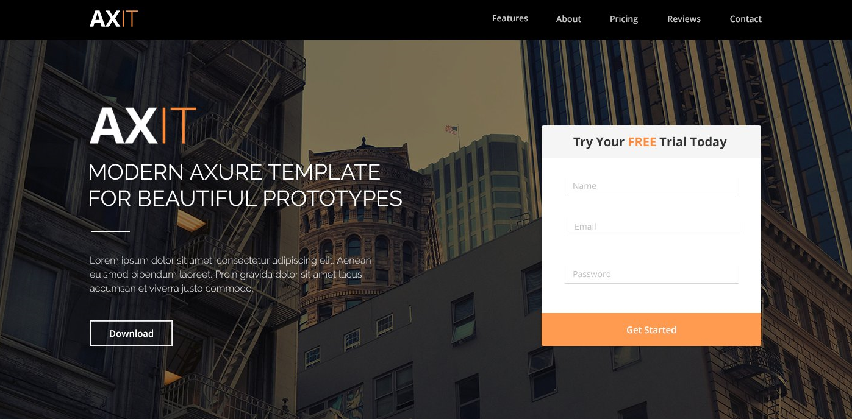

**2.2 Software Requirements**

**HTML:** HTML, or Hypertext Markup Language, is the standard language for creating and designing web pages. It structures web content such as text, images, links, and multimedia, serving as the foundation for web development. HTML is usually combined with technologies like CSS (Cascading Style Sheets) and JavaScript to build interactive and visually appealing websites. Created by British computer scientist Sir Tim Berners-Lee in the early 1990s at CERN (the European Organization for Nuclear Research), the first version, HTML 1.0, was released in 1993 to facilitate document sharing among researchers. HTML structures web pages using elements enclosed in tags, defining content and layout. Adhering to standards and validating HTML documents is crucial for ensuring correct syntax, structure, and compatibility across various web browsers and devices.

**CSS:** Cascading Style Sheets (CSS) is an essential tool for designing and styling web pages, ensuring that a website looks visually appealing and functions seamlessly across various devices. For a photoshoot website, CSS plays a critical role in creating a professional and engaging user experience. By controlling the layout, typography, colors, and responsive design, CSS allows the website to showcase high-quality images and content effectively. The use of CSS ensures that elements such as headers, navigation menus, and galleries are not only aesthetically pleasing but also intuitive and easy to navigate.

**JavaScript:** JavaScript, commonly known as JS, is a high-level, interpreted programming language widely used for developing interactive and dynamic web content. Created by Brendan Eich during his tenure at Netscape Communications Corporation, the initial version of JavaScript, initially called Mocha, was developed in just ten days in May 1995.

**React:** React is a powerful JavaScript library for building user interfaces, particularly well-suited for creating dynamic and responsive web applications. For a photoshoot website, React offers several advantages that enhance both the user and developer experience. By utilizing React's component-based architecture, developers can create reusable UI components such as galleries, sliders, and contact forms, ensuring consistent design and functionality throughout the site. React's virtual DOM improves performance by efficiently updating and rendering only the necessary parts of the page, providing a smooth and fast user experience. Additionally, React's robust ecosystem, including tools like React Router for seamless navigation and state management libraries like Redux, enables the development of complex, interactive features.

# Proposed Design/Methodology

## File Structure

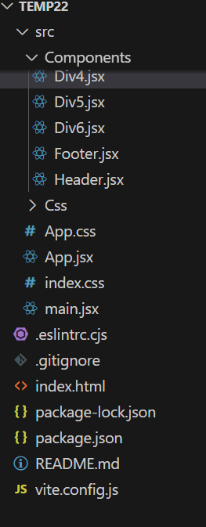 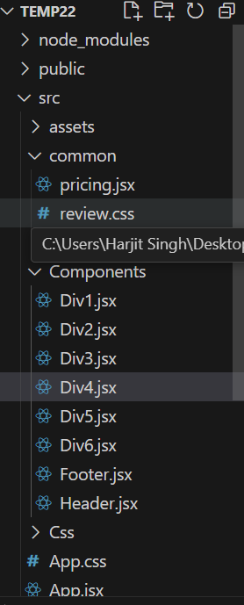

* **index.html**:Contains the basic structure of webpage
* **package.json** : It is a crucial file in any Node.js project, including React applications. It serves as the manifest file that defines the project’s metadata, dependencies, scripts, and other configurations.
* **App.css :** It contains css file structure which enables us to design the website.
* **App.jsx :** serves as the root component, functioning as the central hub for managing and rendering the overall structure and content of the website.
* **Main.jsx** : Typically serves as the entry point for rendering the root component (app.jsx) to the DOM.
* **vite.config.js:** vite.config.js is the configuration file for Vite, a build tool that provides a fast and efficient development environment for modern web applications.
* **.gitignore**: A **.**gitignore file specifies which files and directories should be ignored by Git. This is important to prevent sensitive information, build artifacts, and other unnecessary files from being committed to the repository.

### **Methodology**

### **HTML Code:**

<!doctype html>

<html lang="en">

  <head>

    <meta charset="UTF-8" />

    <link rel="icon" type="image/svg+xml" href="/vite.svg" />

    <meta name="viewport" content="width=device-width, initial-scale=1.0" />

    <title>Vite + React</title>

  </head>

  <body>

    <div id="root"></div>

    <script type="module" src="/src/main.jsx"></script>

  </body>

</html>

### **Header:**

### 

### 

// import React from 'react'

import SignupForm from './Div6'

import '../Css/Header.css'

const Header = () => {

  return (

    <>

    <header className="header">

  <div className="navbar">

  <div className="navbar">

  <div className="row group">

    <img className="logo" src="https://i.ibb.co/9TVznXx/logo-2.png" alt="Logo" />

    <a href="#contact" className="contact">Contact</a>

    <a href="#reviews" className="reviews">Reviews</a>

    <a href="#pricing" className="pricing">Pricing</a>

    <a href="#about" className="about">About</a>

    <a href="#features" className="features">Features</a>

  </div>

</div>

    <div className="divider" />

  </div>

  <div className="row-4 group">

    <div className="col-11">

      <img className="logo-2" src="https://i.ibb.co/02BcHFV/logo.png" alt="" />

      <p className="text">

        MODERN AXURE TEMPLATE

        <br />

        FOR BEAUTIFUL PROTOTYPES

      </p>

      <img

        className="divider_white_u72"

        src="images/divider_white_u72_copy.png"

        alt=""

      />

      <p className="text-2">

        Lorem ipsum dolor sit amet, consectetur adipiscing elit. Aenean

        <br />

        euismod bibendum laoreet. Proin gravida dolor sit amet lacus

        <br />

        accumsan et viverra justo commodo.

      </p>

      <button className="download-button-holder">Download</button>

    </div>

    <SignupForm/>

  </div>

</header>

    </>

  )

}

export default Header

### **First Page:**

### 

import React from 'react'

import '../Css/Div1.css'

const Div1 = () => {

  return (

    <>

    <>

  <div className="brand-bar group">

    <div className="col-4">

      <p className="text-5">Social Media</p>

      <p className="text-6">

        Lorem ipsum dolor sit amet, consectetur adipiscing elit.

        <br />

        Aenean euismod bibendum laoreet.

      </p>

    </div>

    <img

      className="social-media-icons"

      src="https://i.ibb.co/SVgh600/social-media-icons.png"

      alt=" "

      title=" "

    />

  </div>

  <div className="features-2 group">

    <div className="feature-1 group">

      <div className="col-10">

        <div className="tab_1_button_u83_selected-holder">

          <div className="text-7">

            <p>TAB 1</p>

          </div>

        </div>

        <div className="tab_2_button_u85_mouseover-holder">

          <div className="text-8">

            <p>TAB 2</p>

          </div>

        </div>

        <div className="tab_3_button_u87_mouseover-holder">

          <div className="text-9">

            <p>TAB 3</p>

          </div>

        </div>

      </div>

      <div className="col-17">

        <p className="text-10">Tabs with soft transitioning effect.</p>

        <p className="text-11">

          Lorem ipsum dolor sit amet, consectetur adipiscing elit. Aenean

          euismod bibendum laoreet. Proin gravida dolor sit amet lacus accumsan

          et viverra justo commodo. Proin sodales pulvinar tempor. Cum sociis

          natoque penatibus et magnis dis parturient montes.

          <br />

          <span className="text-style">&nbsp;</span>

          <br />

          Lorem ipsum dolor sit amet, consectetur adipiscing elit. Aenean

          euismod bibendum laoreet.

        </p>

        <button class="btn_primary_u98-holder">Download</button>

      </div>

      <img

        className="image_right_u255"

        src="https://i.ibb.co/6PXsxyn/image-right-u255.png"

        alt=""

      />

    </div>

  </div>

</>

    </>

  )

}

export default Div1

### Second Page:

### 

import React from 'react'

import '../Css/Div2.css'

const Div2 = () => {

  return (

    <>

  <div id='features' className="feature-2 group">

    <img

      className="image_left_sub_list_u260"

      src="https://i.ibb.co/3Syy61B/image-left-sub-list-u260.png"

      alt=""

    />

    <div className="col-16">

      <p className="text-12">Sub list section</p>

      <div className="divider_orange_u7-copy-4" />

      <p className="text-13">

        Lorem ipsum dolor sit amet, consectetur adipiscing elit. Aenean

        <br />

        euismod bibendum laoreet. Proin gravida dolor sit amet lacus

        <br />

        accumsan et viverra justo commodo.

      </p>

      <div className="row-12 group">

        <div className="list_icon_upload_u127-holder">

          <img className="text-14" src="https://i.ibb.co/gmsvrJB/image-6.png" alt="" title="" />

        </div>

        <div className="col-23">

          <p className="title">Title</p>

          <p className="text-15">

            Lorem ipsum dolor sit amet, consectetur adipiscing elit.

            <br />

            Aenean euismod bibendum laoreet.

          </p>

        </div>

      </div>

      <div className="row-11 group">

        <div className="list_icon_upload_u127-copy-holder">

          <img className="text-16" src="https://i.ibb.co/VxxHGPT/image-5.png" alt="" title="" />

        </div>

        <div className="col-22">

          <p className="text-17">Title</p>

          <p className="text-18">

            Lorem ipsum dolor sit amet, consectetur adipiscing elit.

            <br />

            Aenean euismod bibendum laoreet. Proin gravida dolor

            <br />

            sit amet lacus accumsan et viverra justo commodo.

          </p>

        </div>

      </div>

    </div>

  </div>

  <div className="feature-3 group">

    <div className="col-9">

      <p className="text-19">Standard Picture Section</p>

      <div className="divider_orange_u7-copy-5" />

      <p className="text-20">

        Lorem ipsum dolor sit amet, consectetur adipiscing elit. Aenean euismod

        bibendum laoreet. Proin gravida dolor sit amet lacus accumsan et viverra

        justo commodo. Proin sodales pulvinar tempor. Cum sociis natoque

        penatibus et magnis dis parturient montes.

        <br />

        <span className="text-style">&nbsp;</span>

        <br />

        Lorem ipsum dolor sit amet, consectetur adipiscing elit. Aenean euismod

        bibendum laoreet.

      </p>

    </div>

    <img

      className="image_right_standard_u262"

      src="https://i.ibb.co/VgbsbRv/image-right-standard-u262.png"

      alt=""

    />

  </div>

  <div id='about' className="our-process group">

    <p className="text-21">WHY THIS IS AWESOME</p>

    <div className="divider_orange_u7-copy-3" />

    <p className="text-22">

      Lorem ipsum dolor sit amet, consectetur adipiscing elit.

    </p>

    <div className="row-3 match-height group">

      <div className="thoughtful-design">

        <div className="icon_awesome_u175-holder">

          <img className="text-23" src="https://i.ibb.co/NmKq3K7/image-3.png"  alt="" title="" />

        </div>

        <p className="text-24">Thoughtful Design</p>

        <p className="text-25">

          Lorem ipsum dolor sit amet, consectetur adipiscing

          <br />

          elit. Aenean euismod bibendum laoreet. Proin gravida

          <br />

          dolor sit amet lacus accumsan et viverra.

        </p>

      </div>

      <div className="well-crafted">

        <div className="icon_awesome_u175-holder-2">

          <img className="text-26" src="https://i.ibb.co/sqC1Wjb/image-2.png"  alt="" title="" />

        </div>

        <p className="text-27">Well Crafted</p>

        <p className="text-28">

          Lorem ipsum dolor sit amet, consectetur adipiscing

          <br />

          elit. Aenean euismod bibendum laoreet. Proin gravida

          <br />

          dolor sit amet lacus accumsan et viverra.

        </p>

      </div>

      <div className="easy-to-customize">

        <div className="icon_awesome_u175-holder-3">

          <img className="text-29" src="https://i.ibb.co/Gx4yMsf/image-4.png"  alt="⬅" title="⬅" />

        </div>

        <p className="text-30">Easy to Customize</p>

        <p className="text-31">

          Lorem ipsum dolor sit amet, consectetur adipiscing

          <br />

          elit. Aenean euismod bibendum laoreet. Proin gravida

          <br />

          dolor sit amet lacus accumsan et viverra.

        </p>

      </div>

    </div>

  </div>

</>

  )

}

export default Div2

### Third Page:

### 

import React from 'react';

import '../Css/Div3.css';

import PricingSlot from '../common/pricing';

const Div3 = () => {

  return (

    <div id='pricing' className="pricing-2 group">

      <PricingSlot

        slotNumber={1}

        planName="Basic"

        price={0}

        subText="Free for Life"

        features={[

          '',

          '10 gb of bandwidth',

          '3 websites',

          'Basic Customization',

          'wordpress integration',

        ]}

      />

      <div className="col-2">

        <p className="text-40">PRICING OPTIONS</p>

        <div className="divider_orange_u7-copy" />

        <p className="text-41">

          Lorem ipsum dolor sit amet, consectetur adipiscing elit.

        </p>

        <div id='p2'>

          <PricingSlot

            slotNumber={2}

            planName="Professional"

            priceTextClass="42"

            price={19}

            dollarClass="3"

            subText="Monthly Payment"

            popularText="OUR MOST POPULAR"

            popularTextClass="44 orange-background" // Added class for orange background

            features={[

              '',

              '50 gb of bandwidth',

              '12 websites',

              'Advanced Customization',

              'wordpress integration',

            ]}

          />

        </div>

      </div>

      <PricingSlot

        slotNumber={3}

        planType="enterprise"

        planName="Enterprise"

        price={70}

        priceTextClass="51"

        dollarClass="3"

        subText="Monthly Payment"

        subTextClass="52"

        features={[

          '',

          'unlimited bandwidth',

          '100 websites',

          'Advanced Customization',

          'wordpress integration',

        ]}

      />

    </div>

  );

}

export default Div3;

### Fourth Page:

### 

// import React from 'react'

import '../Css/Div4.css'

import Testimonial from '../common/review'

const Div4 = () => {

  return (

    <div id='reviews' className="testimonials group">

  <p className="text-59">WHAT OUR CUSTOMERS ARE SAYING</p>

  <div className="divider_orange_u7" />

  <p className="text-60">

    Lorem ipsum dolor sit amet, consectetur adipiscing elit.

  </p>

  <div className="row-2 match-height group">

  <Testimonial

        testimonialNumber={1}

        textContent="Lorem ipsum dolor sit amet, consectetur adipisicing elit. Doloribus accusamus expedita repellat similique odio aspernatur ex, architecto eaque quo suscipit."

        textContentClass="61"

        avatarSrc="images/avatar_2_u231.png"

        name="Jeremy H."

        nameClass="62"

        role="Manager"

      />

<Testimonial

        testimonialNumber={1}

        textContent="Lorem ipsum dolor sit amet, consectetur adipisicing elit. Doloribus accusamus expedita repellat similique odio aspernatur ex, architecto eaque quo suscipit."

        textContentClass="61"

        avatarSrc="images/avatar_2_u231.png"

        name="John S."

        nameClass="62"

        role="Freelancer"

      />

<div id="test3">

<Testimonial

        testimonialNumber={1}

        textContent="Lorem ipsum dolor sit amet, consectetur adipisicing elit. Doloribus accusamus expedita repellat similique odio aspernatur ex, architecto eaque quo suscipit."

        textContentClass="61"

        avatarSrc="images/avatar_2_u231.png"

        name="Susan W."

        nameClass="62"

        role="Photographer"

      />

      </div>

  </div>

</div>

  )

}

export default Div4

### Fifth Page:

### 

import React from 'react'

import '../Css/Div5.css'

const Div5 = () => {

  return (

    <>

    <div className="custom-section group">

  <p className="text-67">STYLISH AXURE DESIGN</p>

  <img

    className="divider_white_u72-copy"

    src="images/divider_white_u72_copy.png"

    alt=""

  />

  <p className="text-68">

    Use the sections you need, remove the ones you don't. &nbsp;Create gorgeous

    prototypes faster than ever!

  </p>

  <button class="download-button-copy-holder">Download</button>

</div>

    </>

  )

}

export default Div5

### Sixth Page:

### 

### 

import React, { useState } from 'react';

import '../Css/Div6.css'; // Ensure you import your CSS file

function SignupForm() {

  const [name, setName] = useState('');

  const [email, setEmail] = useState('');

  const [password, setPassword] = useState('');

  const handleSubmit = (e) => {

    e.preventDefault();

    // Handle form submission logic here, such as sending data to a server

    console.log('Name:', name);

    console.log('Email:', email);

    console.log('Password:', password);

  };

  return (

    <div className="signup">

      <div className="card_header_u257-1-holder">

        Try Your <span className="colorff8b38">FREE</span> Trial Today

      </div>

      <form onSubmit={handleSubmit}>

        <div className="name_input_container_u191-copy-4-holder">

          <label htmlFor="name">Name</label>

          <input

            type="text"

            id="name"

            value={name}

            onChange={(e) => setName(e.target.value)}

            placeholder="Enter your name"

            className='white-background'

          />

        </div>

        <div className="name_input_container_u191-copy-5-holder">

          <label htmlFor="email">Email</label>

          <input

            type="email"

            id="email"

            value={email}

            onChange={(e) => setEmail(e.target.value)}

            placeholder="Enter your email"

            className='white-background'

          />

        </div>

        <div className="name_input_container_u191-copy-6-holder">

          <label htmlFor="password">Password</label>

          <input

            type="password"

            id="password"

            value={password}

            onChange={(e) => setPassword(e.target.value)}

            placeholder="Enter your password"

            className='white-background'

          />

        </div>

        <div className="btn_primary_block_level_u79_mouseover-holder">

          <button type="submit">Get Started</button>

        </div>

      </form>

    </div>

  );

}

export default SignupForm;

### Footer:

### 

import React from 'react';

import '../Css/Footer.css';

const Footer = () => {

  return (

    <footer id='contact' className="footer">

      <div className="contact-us">

        <p className="text-70">CONTACT US</p>

        <div className="divider_orange_u7-copy-2" />

        <p className="text-71">

          Lorem ipsum dolor sit amet, consectetur adipiscing elit.

        </p>

        <form className="contact-form">

          <div className="row-5 group">

            <label htmlFor="first_name" className="name_input_container_u191-holder">First Name</label>

            <input type="text" id="first_name" name="first_name" className="message white-background" placeholder="Enter your first name" required />

          </div>

          <div className="row-6 match-height group">

            <label htmlFor="subject" className="name_input_container_u191-copy-2-holder">Subject</label>

            <input type="text" id="subject" name="subject" className="name_input_container_u191-copy-3 white-background" placeholder="Enter subject" required />

          </div>

          <div className="row-6 match-height group">

            <label htmlFor="message" className="name_input_container_u191-copy-2-holder">Message</label>

            <textarea id="message" name="message" className="name_input_container_u191-copy-3 white-background" placeholder="Enter your message" required></textarea>

          </div>

          <button type="submit" className="btn_primary_u188_mouseover-holder">Send Message</button>

        </form>

      </div>

      <div className="footer-2">

        <img

          className="text-73"

          src="https://i.ibb.co/HrJD2h9/image.png"

          alt="      "

          title="      "

        />

        <p className="text-74">© 2015 Axure Themes</p>

      </div>

    </footer>

  );

}

export default Footer;

# Results:

### In this section, the working website is shown along with its features.

1. User-Friendly Interface

Clean Design: A modern, clean layout that is visually appealing and easy to navigate.

Responsive Layout: The web page is optimized for various devices, ensuring a consistent user experience across desktops, tablets, and smartphones.

1. Comprehensive Information

Detailed Overview: An in-depth introduction and summary of the AXIT Modern Axure Template, highlighting its purpose, significance, and benefits.

Feature Highlights: A section dedicated to outlining the key features of the template, such as customizable components, interactive prototyping, and responsive design elements.

1. Social Media Integration

Social Sharing: Buttons for sharing the page on various social media platforms, helping to spread the word and build a community around the template.

Follow Us: Links to the template's social media profiles, allowing users to stay updated with the latest news and updates.

# Conclusion

The AXIT Modern Axure Template project stands as a pivotal resource for UX/UI designers aiming to enhance their prototyping process. By combining modern aesthetics with functional efficiency, this template offers a robust foundation for creating high-fidelity prototypes that are both visually appealing and highly interactive.

Moreover, the template's ability to streamline collaboration and adapt to the latest technological trends makes it an indispensable tool in any designer’s toolkit. By empowering designers to produce top-quality prototypes quickly and efficiently, the AXIT Modern Axure Template fosters a more productive and creative design environment.

In conclusion, the AXIT Modern Axure Template project significantly contributes to the field of UX/UI design by providing the tools necessary to create beautiful, effective prototypes with ease. It is a valuable asset that enhances design quality, facilitates collaboration, and supports a user-centered approach, ultimately leading to the creation of superior digital products.

# References:

React Documentation: <https://react.dev/blog/2023/03/16/introducing-react-dev>

W3Schools - JavaScript: <https://www.w3schools.com/js/>

W3Schools - HTML and CSS Tutorials: <https://www.w3schools.com/html/default.asp>